**Промежуточная итоговая аттестация по английскому языку (базовый уровень) 11 класс**

**Условия и порядок выполнения работы (время):**

45 минут (радел «Чтение» 15 минут; раздел «Лексика и грамматика» - 30 минут).

**Работа состоит из двух разделов:**

Раздел I «Лексика и Грамматика» содержит 5 заданий (34 балла).

Раздел II «Чтение» (3 балла) содержит одно задание.

**Система оценки выполнения отдельных заданий и работы в целом.**

34 (91%) – 37 (100%) баллов – «отлично»

26 (70%) – 33 (90%) баллов – «хорошо»

19 (50%) – 25 (69 %) баллов – «удовлетворительно»

18 (49%) – 0 баллов – «неудовлетворительно»

**Кодификатор**

1. Видо-временные формы глагола
2. Использование предлогов, а также предлогов в фразовых глаголах
3. Словообразование
4. Чтение и понимание текста.

***Part I. Grammar and Vocabulary.***

**1. Fill in: preserve, irresistible, satellite, confess, separated, abandoned, achieve, burglar, single, cope.**

1.When she _____________________ from her husband, she moved to her parents’ house.

2.It’s difficult to be a _____________________ parent.

3.He can’t _________________________ with stress.

4.They caught the _______________________ red-handed as he was carrying the stolen TV out of the house.

5.Did the man _________________________ to the fraud?

6.It was an __________________________ challenge for the two man to climb Siula Grande.

7.In the industrial part of the city there are a lot of ___________________________ warehouses because businesses have moved away.

8.The first ______________________________ was put into orbit by the Russians in 1957.

9.Kevin is determined to ________________________ his goal of becoming a lawer.

10.The World heritage Organisation works hard to _________________________ ancient sites.

***2. Put the verbs in the correct form***

1. We (go) __________________to the flea market yesterday.

2. Have you typed the contract yet? – Actually, I just (start) ____________________before you (walk) ______________________in.

3. When (retire) ___________________________your dad?

4. I’m tired of (play) __________________________computer games.

5. I can’t stand (watch) _____________________horror films.

6. I can’t wait (tell) ___________________Tina the good news.

7. He is old enough (drive) ______________________a car.

8. The Great Sphinx (build) ________________________________thousands of years ago.

9. I think there’s someone behind us. – Yes, we (follow)____________________________.

10. The new hospital (open) _____________________by the Prime minister next Monday.

***3. Fill in the correct prepositions of the phrasal verbs***

1. We **came** ___________ a beautiful antique table at the flea market. 2. Due to the snow we **put** __________ our trip. 3. **Keep** ________________ from unlit areas at night. 4. Why don’t this toothache **go** _________________? 5. Moving house completely **did** me _________________.

***4. Fill in the correct preposition***

1. Pay attention ______________ the teacher’s instructions.

2. Why do you always insist _____________ sitting here?

3. Jane recovered __________________ her illness very quickly.

***5. Fill in the correct word derived from the word in bold***

1. Please, express your ____________________ with new rules directly. **DISAGREE**
2. Jack stared at Helen in __________________ **AMAZE**
3. Stay in our comfortable ___________________ and relax in style! **ACCOMMODATE**
4. It’s ______________________ to buy cigarettes in Britain if you’re under 16. **legal**
5. They admitted that it had been _____________________ for him to comment on the matter. **appropriate**
6. He was _________________________ single-minded about his career. **possible**

**Part II. Reading.**

**Read a magazine article about eco-projects. For questions 1-3 choose from the projects A-D.**

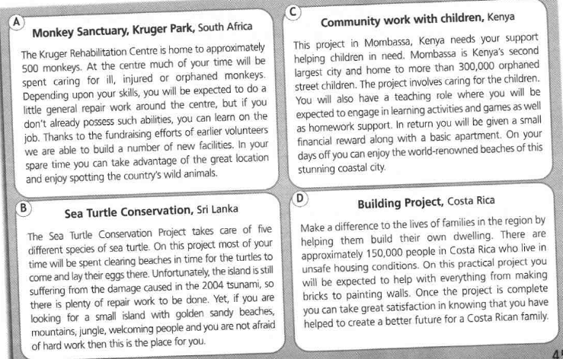

**Which project:**

1. constructs accommodation for local residents?
2. involves looking after the breeding areas of animals?
3. teaches participants new skils?

Ключи.

***Part I. Grammar and Vocabulary.***

**1. Fill in:**

1. separated 2. Single 3. Cope 4. Burglar 5. Confess 6. Irresistible 7. Abandoned 8. satellite

9. achieve 10. preserve

***2. Put the verbs in the correct form***

1. We **went**to the flea market yesterday.

2. Have you typed the contract yet? – Actually, I **had just started** before you walked in.

3. When **did** your dad **retire**?

4. I’m tired of **playing** computer games.

5. I can’t stand **watching** horror films.

6. I can’t wait **to tell** Tina the good news.

7. He is old enough **to drive** a car.

8. The Great Sphinx **was built** thousands of years ago.

9. I think there’s someone behind us. – Yes, we **are being followed**.

10. The new hospital **will be opened** by the Prime minister next Monday.

***3. Fill in the correct prepositions of the phrasal verbs***

1. We **came** **across** a beautiful antique table at the flea market. 2. Due to the snow we **put** **off**our trip. 3. **Keep** **away** from unlit areas at night. 4. Why don’t this toothache **go** **away**? 5. Moving house completely **did** me **in**.

***4. Fill in the correct preposition***

1. Pay attention **to** the teacher’s instructions.

2. Why do you always insist **on** sitting here?

3. Jane recovered **from** her illness very quickly.

***5. Fill in the correct word derived from the word in bold***

1. disagreement
2. amazement
3. accomodation
4. illegal
5. inappropriate
6. impossibly

**Part II. Reading.**

**Read a magazine article about eco-projects. For questions 1-3 choose from the projects A-D.**

1. C 2. B 3. A