Промежуточная итоговая аттестация по английскому языку (базовый уровень) 11 класс
ФИО ______________________________________________________________________
Вариант 1
Part I. Grammar and Vocabulary.
1. Fill in: preserve, irresistible, satellite, confess, separated, abandoned, achieve, burglar, single, cope.
  - When she __ from her husband, she moved to her parents’ house.
  - It’s difficult to be a __ parent.
  - He can’t __ with stress.
  - They caught the __ red-handed as he was carrying the stolen TV out of the house.
  - Did the man __ to the fraud?
  - It was an __ challenge for the two man to climb Siula Grande.
  - In the industrial part of the city there are a lot of __ warehouses because businesses have moved away.
  - The first __ was put into orbit by the Russians in 1957.
  - Kevin is determined to __ his goal of becoming a lawer.
  - The World heritage Organisation works hard to __ ancient sites.
2. Put the verbs in the correct form
1. We (go) to the flea market yesterday.
2. Have you typed the contract yet? – Actually I just (start) before you (walk) in.
3. When (retire) your dad?
4. I’m tired of (play) computer games.
5. I can’t stand (watch) horror films.
6. I can’t wait (tell) Tina the good news.
7. He is old enough (drive) a car.
8. The Great Sphinx (build) thousands of years ago.
9. I think there’s someone behind us. – Yes, we (follow).
10. The new hospital (open) by the Prime minister next Monday.
3. Fill in the correct prepositions of the phrasal verbs
1. We came __ a beautiful antique table at the flea market. 2. Due to the snow we put __ our trip. 3. Keep __ from unlit areas at night. 4. Why don’t this toothache go __? 5. Moving house completely did me __.
4. Fill in the correct preposition
1. Pay attention __ the teacher’s instructions.
2. Why do you always insist __ sitting here?
3. Jane recovered __ her illness very quickly.
5. Fill in the correct word derived from the word in bold
- Please, express your _____ with new rules directly. DISAGREE
- Jack stared at Helen in _____ AMAZE
- Stay in our comfortable _____ and relax in style! ACCOMMODATE
- It’s _____ to buy cigarettes in Britain if you’re under 16. legal
- They admitted that it had been _____ for him to comment on the matter. appropriate
- He was _____ single-minded about his career. possible
Part II. Reading.
Read a magazine article about eco-projects. For questions 1-3 choose from the projects A-D.
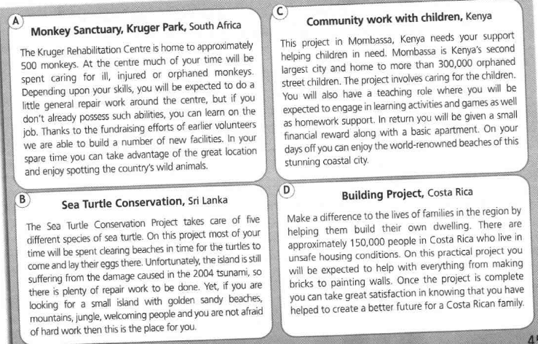
Which project:
- constructs accommodation for local residents?
- involves looking after the breeding areas of animals?
- teaches participants new skils?

